Girder Model Editor

View Settings
The Girder Model Settings dialog provides an interface for manipulating the settings of the Girder Model view. The dialog is divided into property pages as described below.

Elevation
This tab contains settings that are specific to the Elevation View pane. When checked, the corresponding display element is enabled.
Setting | Description
Show Strands | The individual prestressing strands are show
Show CG of Prestress Force | The center of gravity of the prestress force is shown
Schematic | When checked, the girder elevation is drawn schematic instead of to scale.

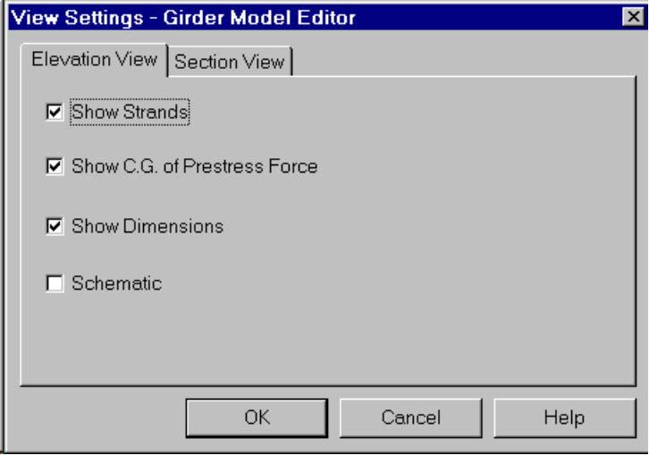
Figure 1 Girder Model View Settings - Elevation

Section
This tab contains settings that are specific to the Section View pane. When checked, the corresponding display element is enabled.
Setting | Description
Show Strands | Displays the individual strands in the girder cross section
Show CG of Prestress Force | The location of the resultant prestress force is shown
Show Dimensions | The cross section dimensions are shown

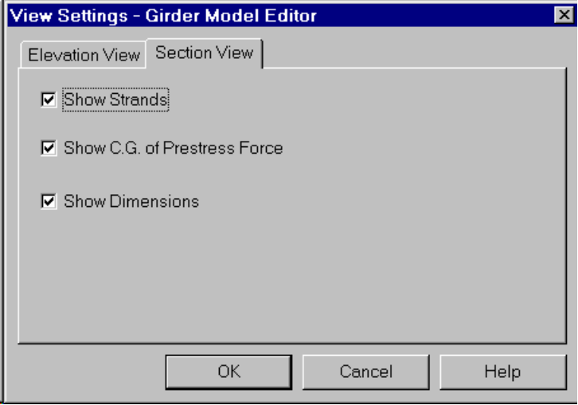
Figure 2 Girder Model View Settings - Section

